**Step for List Fleets:**

1. **You can access the fleets module on by going on this page:**

<http://143.198.214.24:2337/admin/plugins/content-manager/collectionType/application::fleet.fleet>

You should be showing this page:

**## This is the list of all the fleets added on our system:**

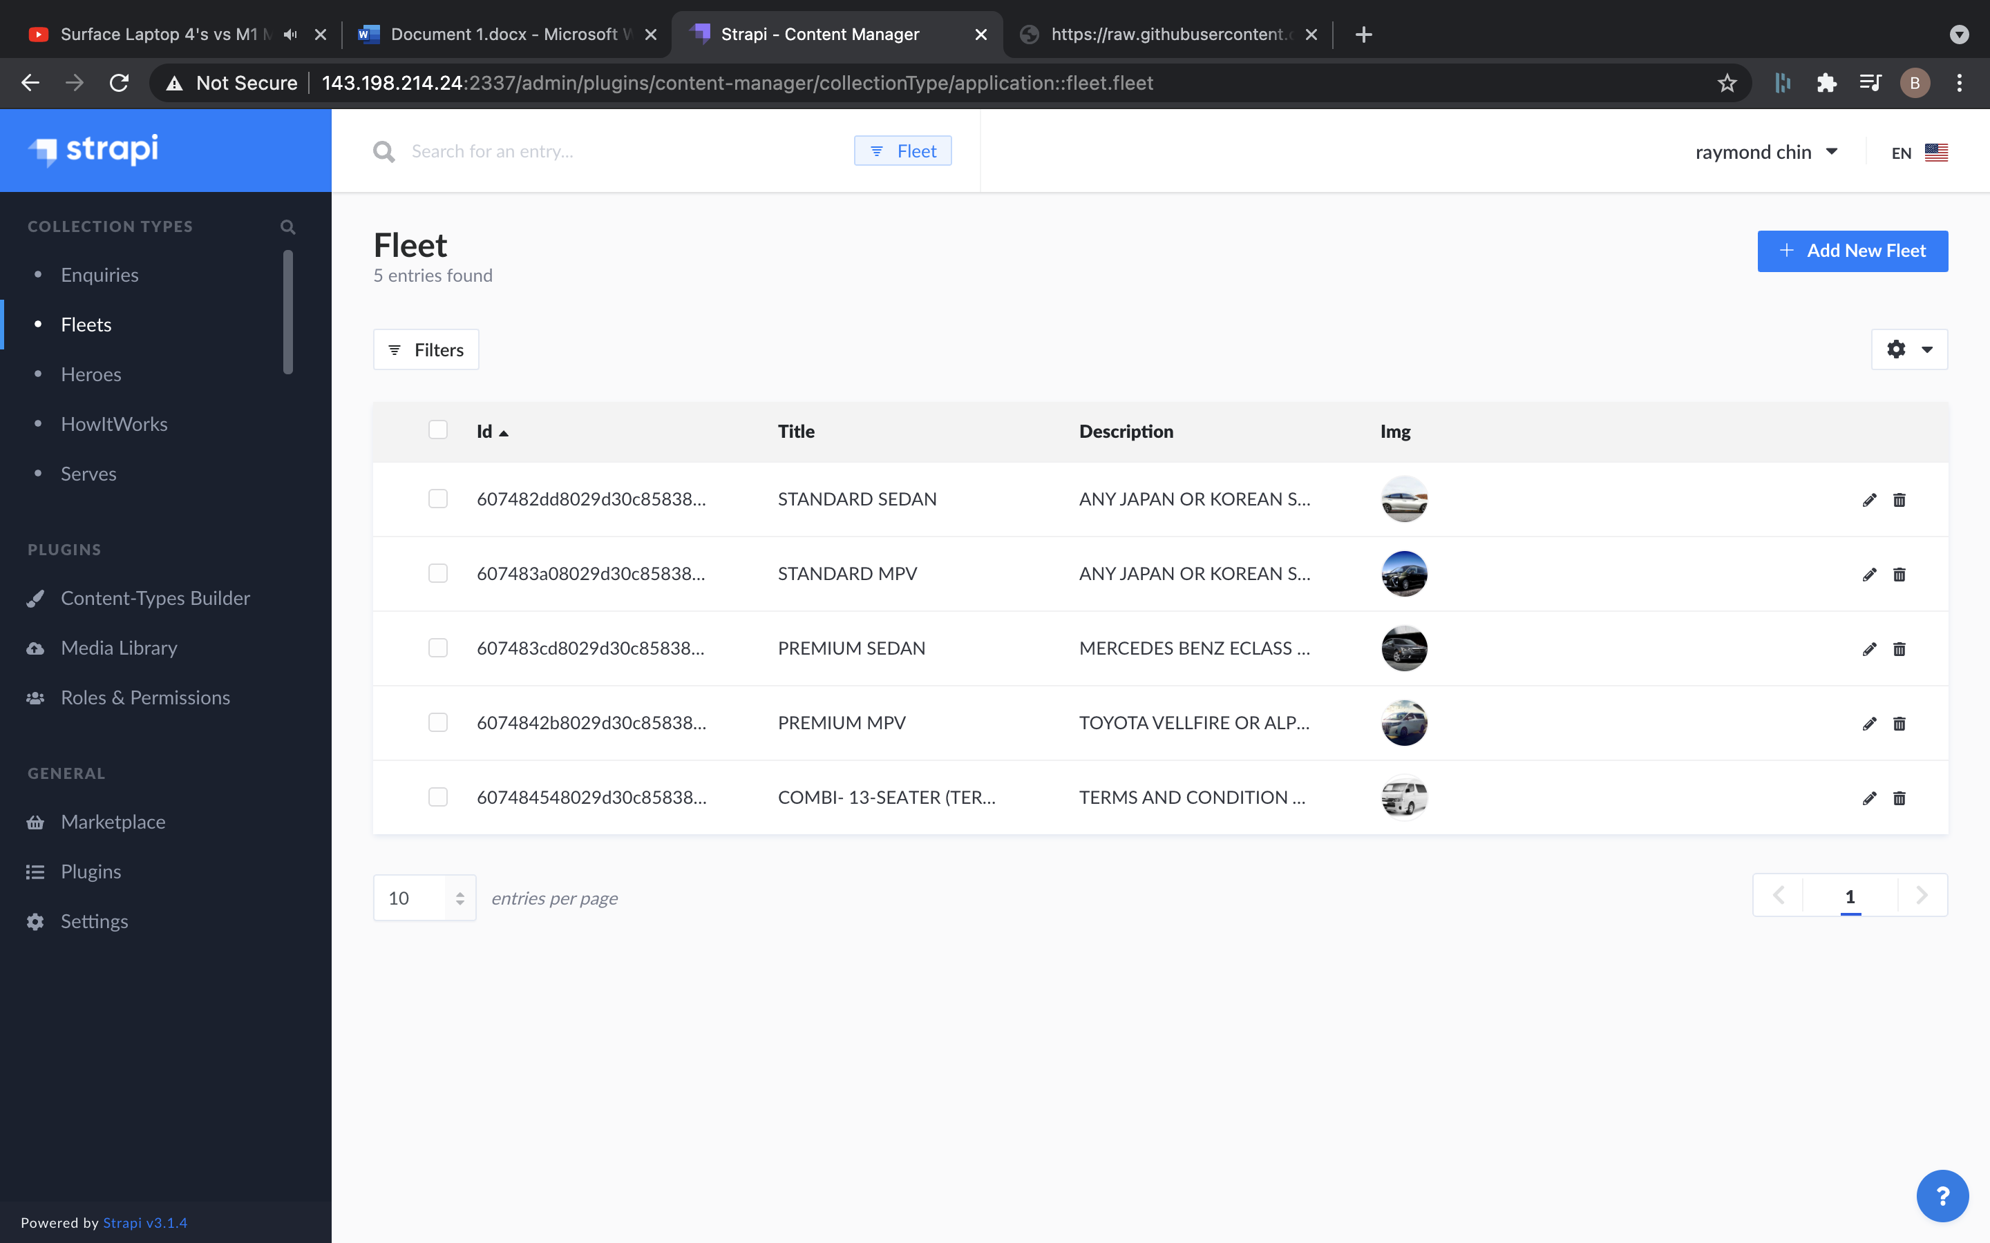

## **Steps for Add new Fleet:**

### **1. Visit add fleet link:**

<http://143.198.214.24:2337/admin/plugins/content-manager/collectionType/application::fleet.fleet/create>

This should be the page shown:

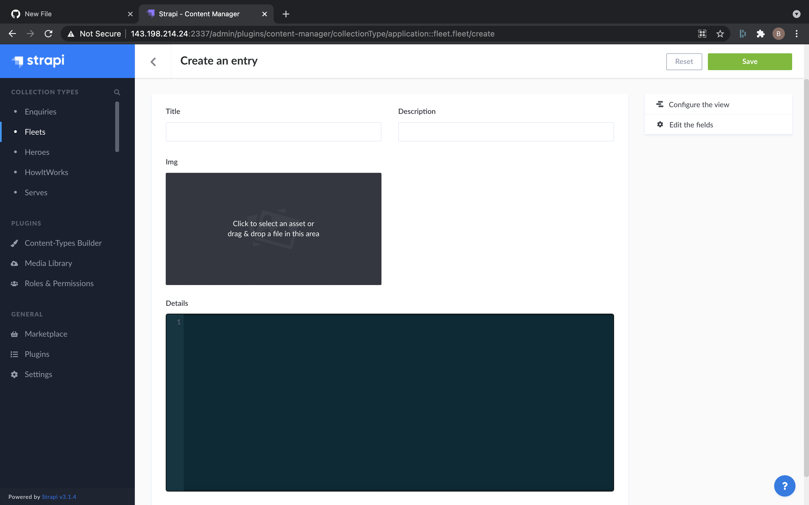

### **2. Add the details for new fleet:**

a. Title : This will be title.

b. Description: This will be the description of fleet

c. Img: This will be the image for fleet , You can add Img by Add More Assets and upload from computer to server.

d. Details:

This will be details of the fleet:

{

"passengers": "3 passengers",

"suitcases": "2 x 25” luggage and 2 x hand carry ",

"airport_arrival": "$45 one-way / $70 return trip",

"city_transfer": "$30 One-way",

"departure": "$35 One-way",

"hourly": "$45 (* Maximum 2 stops) / $40 for 2hrs above",

"extra_stop": "$10 (Within destination route) / $15 (outside destination route)"

}

This is structure for the fleet details.

### **3. Click on save button on top right to save the new fleet.**

## **Steps for delete of fleet are:**

### **1. Go to List of Fleets:**

<http://143.198.214.24:2337/admin/plugins/content-manager/collectionType/application::fleet.fleet>

### **2. Click on Fleet that need to delete:**

It should open the fleet detail, confirm all the details and make sure:

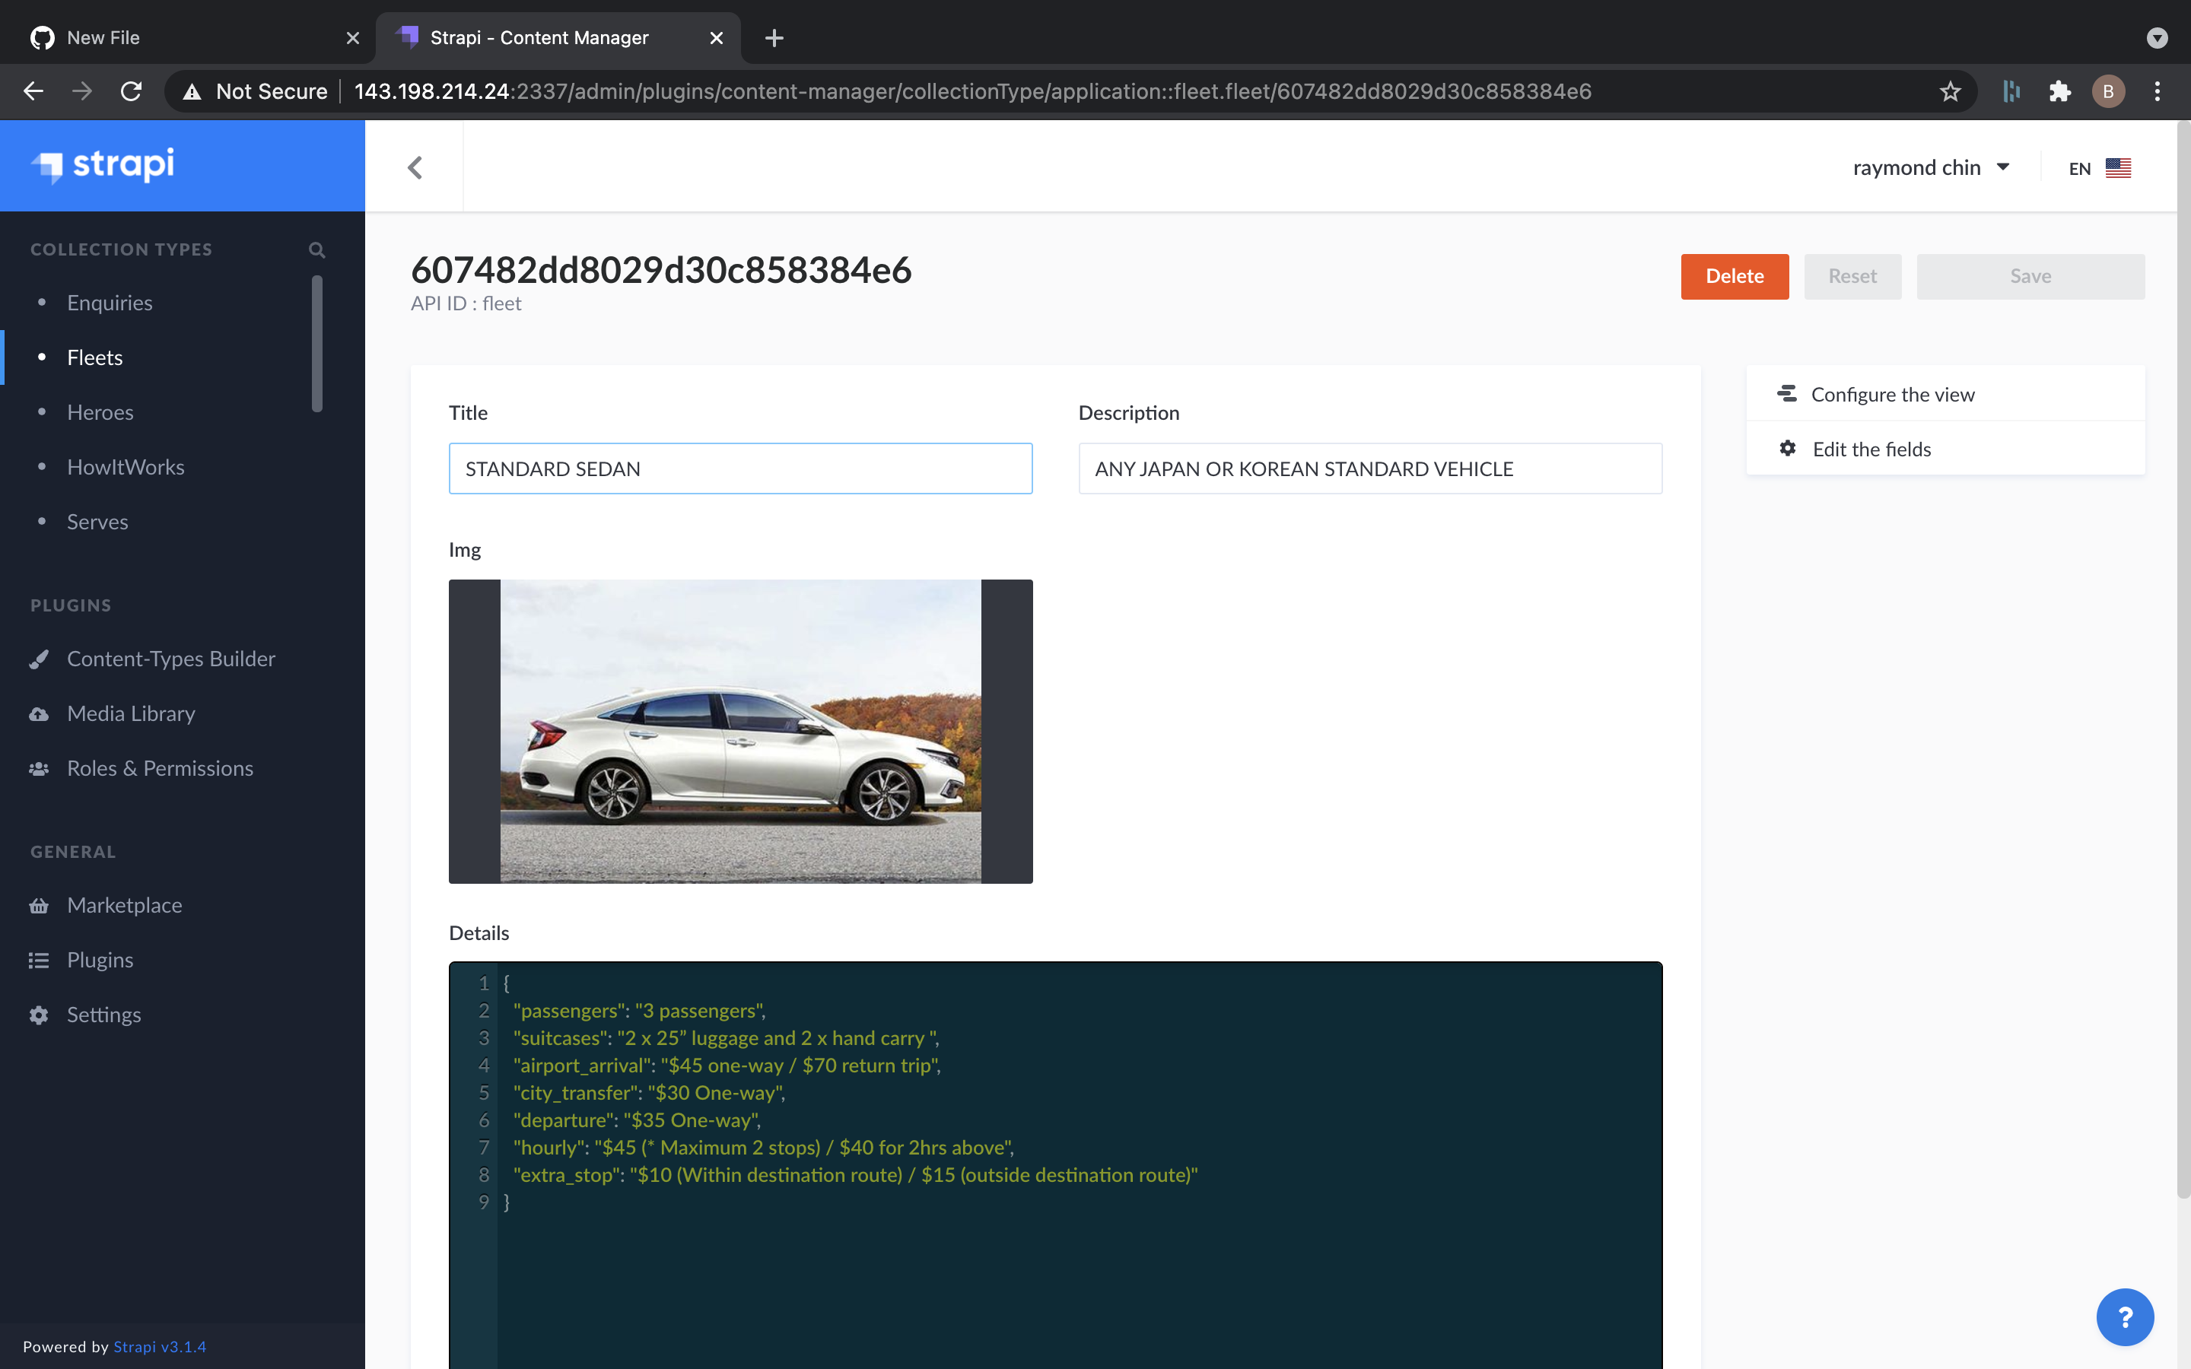

### **3. Click on delete button on top right:**

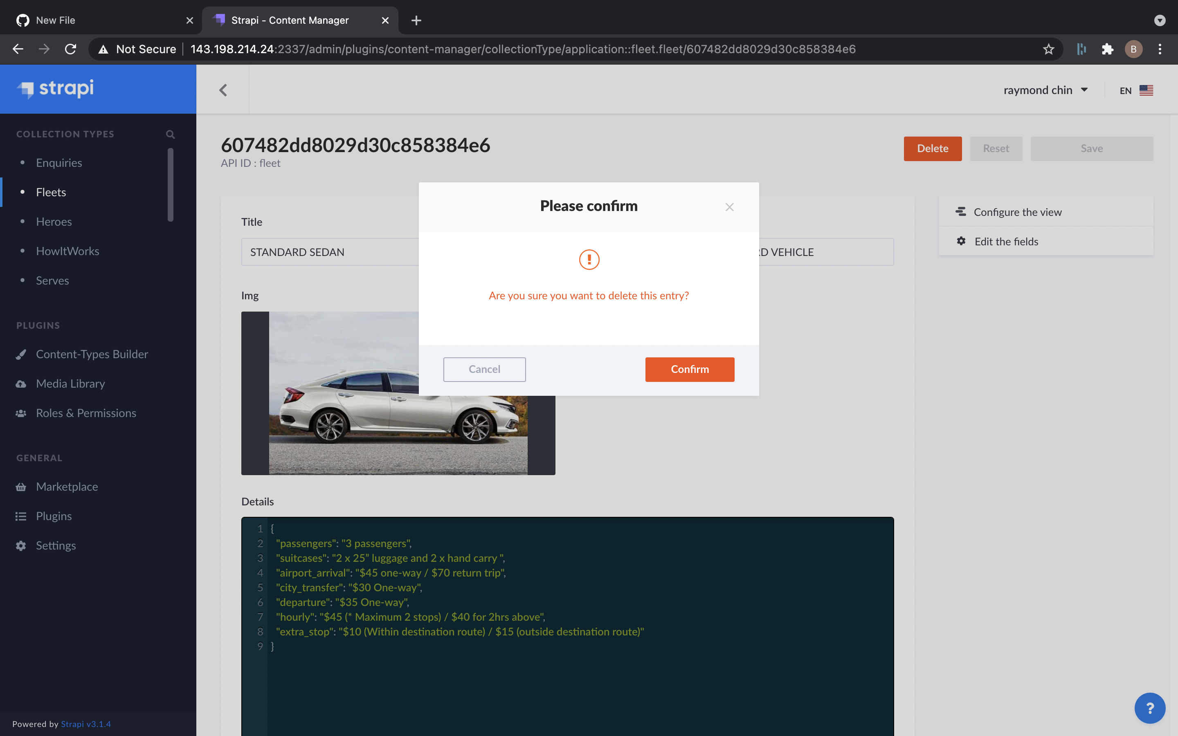

### **4. Click on Confirm to Delete.**

## **Steps for Edit Fleet:**

### **1. Go to List of Fleets:**

<http://143.198.214.24:2337/admin/plugins/content-manager/collectionType/application::fleet.fleet>

### **2. Click on Fleet that need to edit:**

It should open the fleet detail, confirm all the details and make sure:



### **3. Edit the details for fleet:**

a. Title: This will be title.

b. Description: This will be the description of fleet

c. Img: This will be the image for fleet, you can add Img by Add More Assets and upload from computer to server.

d. Details:

This will be details of the fleet:

{

"passengers": "3 passengers",

"suitcases": "2 x 25” luggage and 2 x hand carry ",

"airport_arrival": "$45 one-way / $70 return trip",

"city_transfer": "$30 One-way",

"departure": "$35 One-way",

"hourly": "$45 (* Maximum 2 stops) / $40 for 2hrs above",

"extra_stop": "$10 (Within destination route) / $15 (outside destination route)"

}

This is structure for the fleet details.

### **4. Click on save button on top right to edit the fleet.**